Impact of Exercise Training on Insulin Sensitivity in Obese Adults  
BIOS 653 Final Project  
Team Kanye’s Workout Plan  
Ji Young Yun, Chris Ahn, Jane Li, Candice Ammori, Allen Li

Abstract

The purpose of this study was to determine the impact of moderate and high intensity exercise training on whole-body insulin sensitivity in obese adults in the absence of weight loss. The basic design of the study involved recruiting 31 sedentary obese adults between the ages of 18 and 40 and randomly assigning them to either moderate or intense exercise. Subjects were tightly monitored and consulted to maintain their body weight throughout the intervention. The study results showed that average insulin sensitivity significantly changed over the three visits (p = 0.0020), for a typical individual with average fat mass and muscle glycogen, after adjusting for sex. Average insulin sensitivity on Visit 2 was significantly different than average insulin sensitivity on Visit 1 for a typical individual with average fat mass and muscle glycogen (p = 0.0005), after adjusting for sex. But, average insulin sensitivity on Visit 3 was not significantly different than average insulin sensitivity on Visit 2 (p = 0.1836) and was not significantly different compared to Visit 1 (p = 0.0977). However, there was no significant difference in insulin sensitivity between exercise groups.

Introduction

Insulin resistance, defined as the state of reduced responsiveness or sensitivity to the metabolic actions of insulin (Katz et al., JCEM, 2000), is closely linked to many metabolic complications including obesity. While weight-loss has been reported to be effective in improving whole-body insulin sensitivity (Magkos et al., 2016), exercise training has continuously been reported to improve metabolic health by increasing insulin sensitivity (Houmard et al., 2004, Short et al., 2003). However, because even modest weight loss can have a profound effect on insulin sensitivity, interpretations from studies examining the direct effects of exercise on insulin sensitivity are often confounded if subjects lose even a rather small amount of body fat mass (Rupnick et al., 2002, Larson-Meyer et al., 2006, Magkos et al., 2016). Furthermore, when it comes to obesity, more evidence is limited.

In recent years, high-intensity interval training (HIIT) has garnered considerable attention because of its time efficiency and distinct physiological impact compared with conventionally recommended moderate-intensity continuous training (MICT) (Weston et al., 2014). It has been reported that HIIT is more effective than MICT at improving blood glucose level which is directly related to insulin sensitivity (Tjonna et al., 2008, Little et al., 2014). Therefore, it is compelling to hypothesize that HIIT may contribute to improving insulin sensitivity more effectively than MICT.

The purpose of this ongoing study (‘Metabolic adaptations in response to high-intensity interval training in obese adults’) proposed by Dr. Horowitz, the principal investigator of the Substrate Metabolism Laboratory, School of Kinesiology, University of Michigan was to determine the impact of exercise training (both HIIT and MICT) on whole-body insulin sensitivity in obese adults in the absence of weight loss. It was hypothesized that both types of exercise training would improve insulin sensitivity and this improvement would persist even though they stop exercising for a few days (i.e. similar insulin sensitivity level on Visit 2 and 3), while this adaptation would be more pronounced in HIIT compared with MICT.

Methods

Experimental method

Subjects

A total of 31 sedentary obese adults (Age: 18-40, BMI: 30-40kg) participated in the study. Recruited subjects were randomly assigned to either MICT (n=15, Female = 10, Male = 5) or HIIT (n=16, Female = 9, Male = 7). All women were pre-menopausal and had regularly occurring menses. All subjects were weight stable and considered to be in good health after a comprehensive medical examination, which included a detailed history and physical examination, routine blood tests, an aerobic fitness test (VO2peak test), and body composition assessment (i.e., dual-energy x-ray absorptiometry). No subject was taking regular medications or had any history of cardiovascular disease and type 2 diabetes. Subjects were tightly monitored and consulted to maintain their body weight throughout the intervention.

Experimental Procedures

An overview of the experimental design is presented in Figure 1. Briefly, on three separate occasions (before, 1-day after, and 3-day after exercise training intervention), subjects were admitted to the Michigan Clinical Research Unit (MCRU) and underwent clinical measurements (anthropometric measurements, biopsy, insulin sensitivity measurements, etc). The first post-training visit occurred the day after subjects’ last session of exercise. In order to wash out potential acute effects of exercise, subjects revisited the clinic after not exercising for 3 days after the first post-training visit.

Exercise training intervention

Subjects underwent a 12-week of HIIT or MICT. Exercise intensity was based on the percentage of each subject’s maximal heart rate (HR max), which was determined during the initial aerobic fitness test. Subjects in MICT group exercised at 65% HR max for 45 minutes, 4 days per week. Subjects in HIIT group exercised at 90% HR max for 10 minutes interspersed with 1-minute low intensity exercise for 4 days per week.

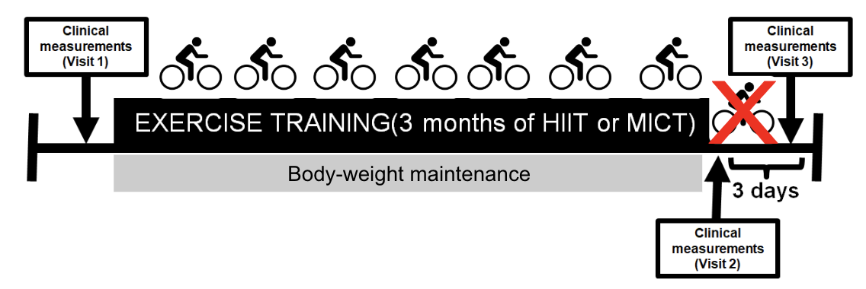

**Figure 1.** Schematic of the study timeline

Statistical methods

Exploratory data analysis

Figure 2 shows a spaghetti plot of each of the subjects divided by the two exercise groups with time (days) on the x-axis and insulin sensitivity on the y-axis. Subjects vary in their baseline insulin sensitivity measurements and their responses over time. In general, values of insulin sensitivity increase from baseline (Visit 1, Day 0) to Visit 2 (90), and decreases from Visit 2 (90) to Visit 3 (93). Subjects on high intensity training have a higher level of insulin sensitivity, although it cannot yet be stated whether this is due to the level of training. It can also be observed that the measurements are not equally spaced. As for the spaghetti plot by sex displayed below, males generally show a higher level of insulin sensitivity despite the fact that the average baseline value for males is lower. Each of the subjects have different levels of insulin sensitivity at baseline and changes over time, although the magnitude of the change is greater for males. It shows a similar pattern of increasing from baseline to Visit 2 and decreasing from Visit 2 to Visit 3.

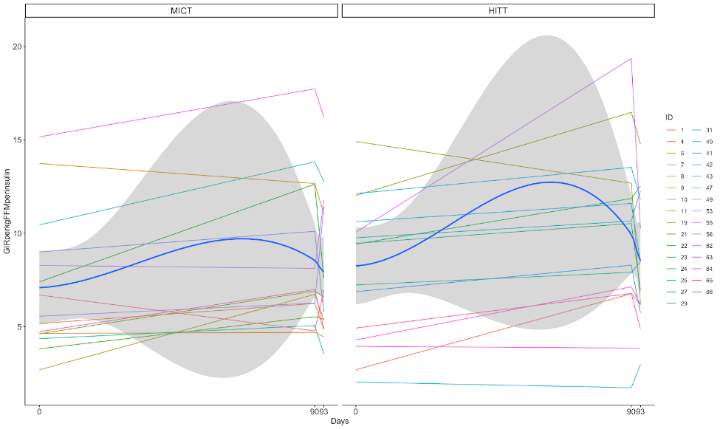

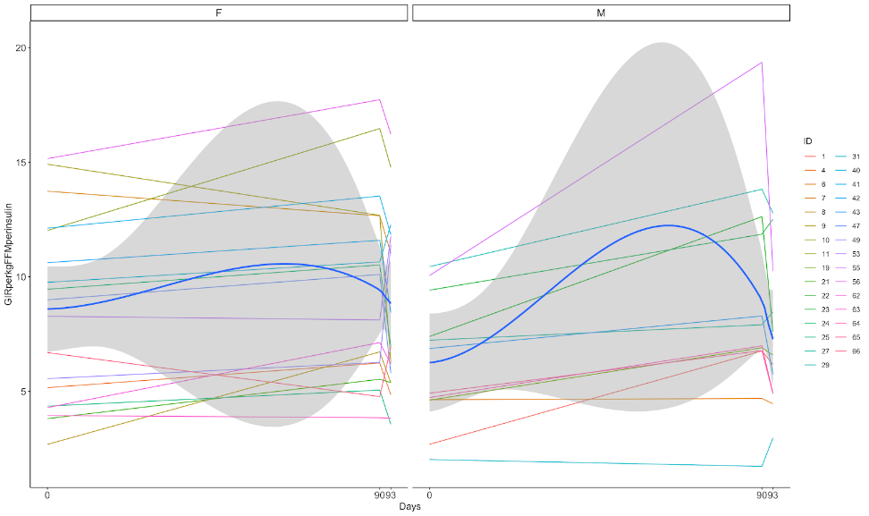

**Figure 2.** Spaghetti plots of data by group (top) and sex (bottom)

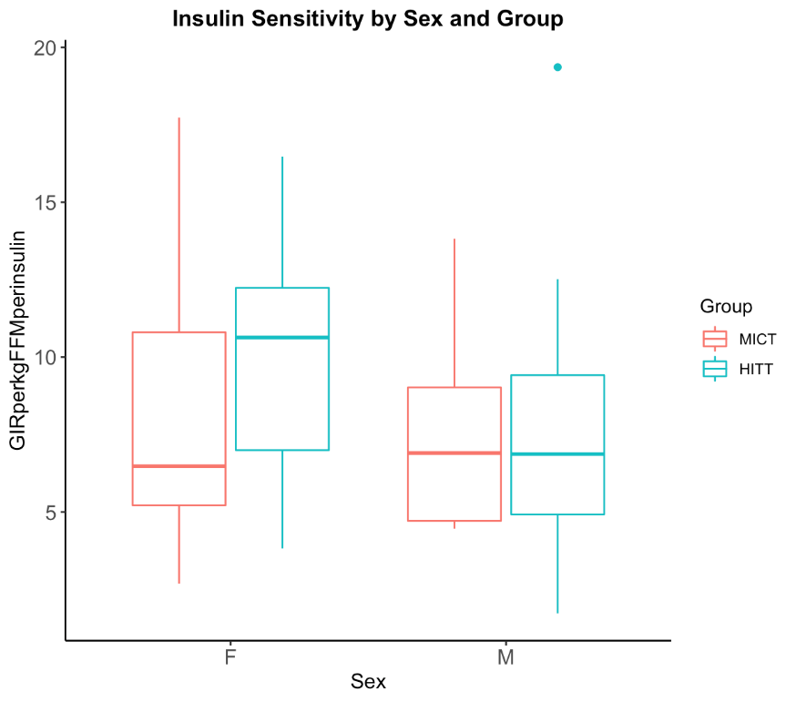

**Figure 3:** Comparison of insulin sensitivity measurements by sex and group

The series of boxplots above demonstrates the distribution of insulin sensitivity measurements by gender and exercise groups. There does not exist a large difference between the two genders, but the difference between the two exercise groups is greater for females.

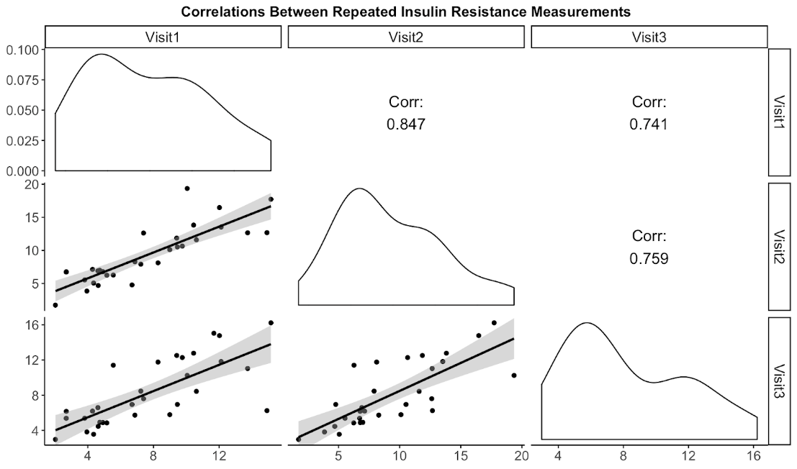

**Figure 4:** Correlations between each time point of insulin sensitivity measurements

The correlations between the measures of insulin sensitivity from the three visits were explored through a matrix of density and scatter plots shown in Figure 4. All three density plots above are peaked at an insulin sensitivity measurement between 4 and 8. The scatterplot and the loess line show positive correlation, which was also stated numerically. Although all three relationships amongst different visits had high positive correlation, the observations from visit 1 and visit 2 were the most correlated, with a correlation of 0.847.

Modeling

Linear mixed effects models were utilized to determine the effect of the training regimens on insulin sensitivity, controlling for variables such as sex, muscle glycogen, and fat mass. This particular model was selected as the main method of analysis because repeated measures are not evenly spaced and the dataset has some individuals with missing measurements, so the ni’s may be not equal across i. In addition, linear mixed models can account for individual specific effects.  According to the spaghetti plot in Figure 2, it appears that individuals are different at baseline for both groups and appear to vary in their rate of change over time. As such, it was appropriate to include terms for subject-specific intercepts and subject-specific slopes for time in the linear mixed effect model. Furthermore, the subject’s ni’s are small, so it was useful to borrow information from other subjects in order to predict the random effects.

The model was built with a population intercept, population slope for time in days, treatment group interaction with time (days), sex, fatmass, and muscle glyocogen. Based on Figure 2, the relationship between insulin sensitivity and time is not quite linear; insulin sensitivity increases from Visit 1 to Visit 2 across nearly all individuals, and then decreases from Visit 2 to Visit 3. Therefore, a categorical form was utilized for the time variable. REML was used to estimate the parameters in our model. A treatment group was not included as the main effect because this is a randomized trial. Sex is modeled as a binary categorical variable. Fatmass and MuscleGlycogen are continuous variables centered by their respective means to improve interpretability of the associated parameter estimates, as no subject with Fatmass or MuscleGlycogen of zero exists. The outcome in the model is scaled insulin sensitivity.

Various variance-covariance structures for the fixed effects models were explored. In Figure 4, the correlation plot suggests that the response contains more variability at Visit 2, and the correlation between Visit 1 and Visit 2 differs from other pairwise comparisons between time points. The model was fit with a variety of variance-covariance structures that were flexible to accommodate different variances at each time point or accommodate differing covariances between pairs of time points. The variance covariance structures fit with the model included unstructured, ARH(1), ANTE(1), and CSH.  For each of these models, an unstructured variance-covariance for the random effects and REML estimation method was attempted. After fitting separate models with these different variance-covariance structures, each model’s AIC, AICc, BIC, and -2 Restricted Log Likelihood (-2 Res Log Lik) values were compared. The variance-covariance structure with the lowest AIC, AICc, BIC, and higher -2 Res Log Lik values was selected. Subsequent analysis used the selected variance-covariance structure.

Based on the spaghetti plots (Figure 2), it was determined that group-specific variance covariance structures for sex and treatment group were not needed. The variation in the male and female plots is not so distinct as to warrant a sex-specific variance-covariance structure. Similarly, the variation in HIIT is similar to that of MICT, so a treatment group-specific variance covariance structure was not applied for fitting.

Based on exploratory data analysis, individual-specific intercepts and slopes were incorporated for the random effects. The need for the random slope for time was assessed by fitting one model including both random intercept and random slope and another model with only the random intercept, and comparing the models using LRT with the proper distribution and degrees of freedom. In this evaluation of the random slope, the variance-covariance structure that was most appropriate given the fit statistics (AIC, BIC, etc) was chosen.

After determining the optimal variance-covariance structure and the need for a random slope for time, the model parameters and model diagnostics based on transformed residuals were evaluated. Residuals versus predicted plots and Q-Q plots were examined to determine whether there were departures from normality. Influence diagnostics was also investigated using Cook’s Distance and PRESS Statistics.

Results

Based on Table 1, the variance-covariance structures with the best fit statistics are ARH(1) and CSH. For the variance-covariance structures, CSH was selected, for it requires fewer degrees of freedom compared to ARH(1) but has the same AIC, AICc, BIC, and -2LogLik values. It was decided that a random slope was not necessary according to the results shown in Table 2. After selecting a variance-covariance structure and evaluating the need for a random

slope, our final model is:

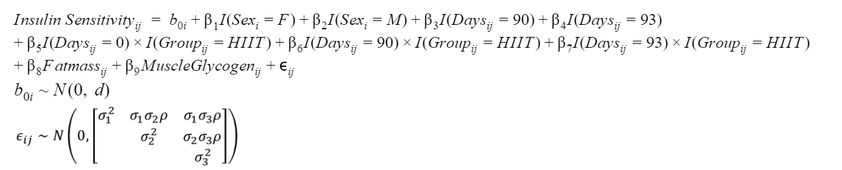

The interpretation of the parameters of interest in the study are as follows:

* $β_{3}$ is the average difference in insulin sensitivity between Visit 2 and Visit 1, for an individual in the MICT group with average fat mass and muscle glycogen, adjusted for sex.
* $β_{4}$ is the average difference in insulin sensitivity between Visit 3 and Visit 1, for an individual in the MICT group with average fat mass and muscle glycogen, adjusted for sex.
* $β_{5}$ is the average difference in insulin sensitivity between HIIT and MICT on Visit 1, for an individual with average fat mass and muscle glycogen, adjusted for sex.
* $β_{6}$ is the average difference in insulin sensitivity between HIIT and MICT on Visit 2, for an individual with average fat mass and muscle glycogen, adjusted for sex.
* $β_{7}$ is the average difference in insulin sensitivity between HIIT and MICT on Visit 3, for an individual with average fat mass and muscle glycogen, adjusted for sex.

The hypotheses stated previously introduced include:

1. Whether insulin sensitivity is changed after 3-months of exercise training,
2. If so, whether the changes in insulin sensitivity persist when subjects go back to their normal life (i.e. stop exercising), and
3. Do the changes in insulin sensitivity over time differ between HIIT and MICT?

Our null and alternative hypotheses for the above hypotheses are as follows:

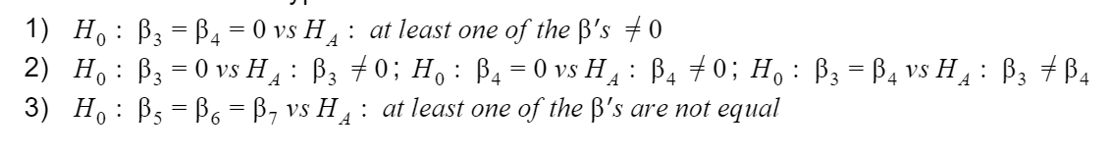

These hypotheses above were tested using contrasts the contrasts in Table 4. For the first hypothesis, it was found that average insulin sensitivity significantly changed over the three visits (p = 0.0020), for a typical individual with average fat mass and muscle glycogen, after adjusting for sex.

For the second set of hypotheses, average insulin sensitivity on Visit 2 was significantly different than average insulin sensitivity on Visit 1 for a typical individual with average fat mass and muscle glycogen (p = 0.0005), after adjusting for sex. Average insulin sensitivity on Visit 3 was not significantly different than average insulin sensitivity on Visit 2 (p = 0.1836) and was not significantly different compared to Visit 1 (p = 0.0977).

For our third hypothesis, where we wish to determine a difference in any of the group-time effects, our contrasts show that we do not have at least one significant difference (p = 0.7137). As this effect isn’t significant, while our time differences are significant, we can infer that the type of exercise training isn’t as important to insulin sensitivity, but consistent exercise will influence insulin sensitivity. Our final model parameters are included in Table 3. Through our model, we have determined that exercise has an effect on insulin sensitivity in our target population.

Finally, Fatmass did not change significantly over time, suggesting that, on average, subjects did maintain their weight over the study, so the effects of exercise on changes in insulin sensitivity are not confounded by expected changes in insulin sensitivity due to weight loss.

**Table 1.** Variance Covariance Structure for Fixed Effects Model

|  |  |  |  |  |
| --- | --- | --- | --- | --- |
| Variance-Covariance Structure1 | -2 Res Log Lik | AIC | AICc | BIC |
| Unstructured2 | -- | -- | -- | -- |
| ARH(1) | 423.4 | 451.4 | 457.9 | 471.0 |
| ANTE(1) | 423.4 | 453.4 | 460.9 | 474.4 |
| CSH | 423.4 | 451.4 | 457.9 | 471.0 |

1 Each model was fit using REML and included a random intercept, random slope for time, and unstructured variance-covariance for random effects model.

2The model with unstructured variance-covariance for the fixed effects did not converge.

Table **2**.  Determining the need for a random slope for time

|  |  |  |  |  |
| --- | --- | --- | --- | --- |
| Random Effects included in model1 | -2 Res Log Lik | AIC | AICc | BIC |
| $$b_{0i} + b1_{i}Day_{ij}$$ | 423.4 | 451.4 | 457.9 | 471.0 |
| $$b_{0i}$$ | 425.6 | 433.6 | 434.1 | 439.2 |
|  | | | | |

1Model utilized REML and CSH variance-covariance structure.

**Table 3.** Fixed Effect Parameter Estimates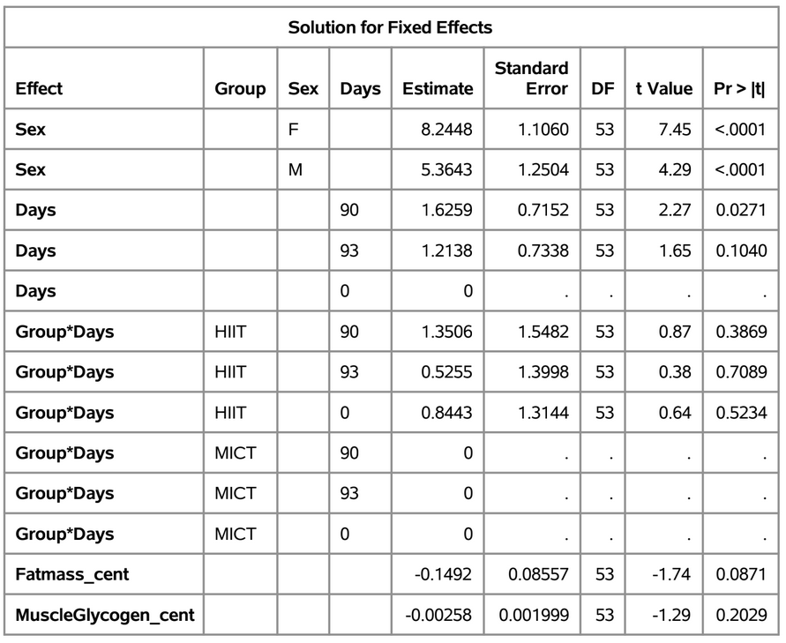

**Table 4.** Hypothesis Test Contrast Results

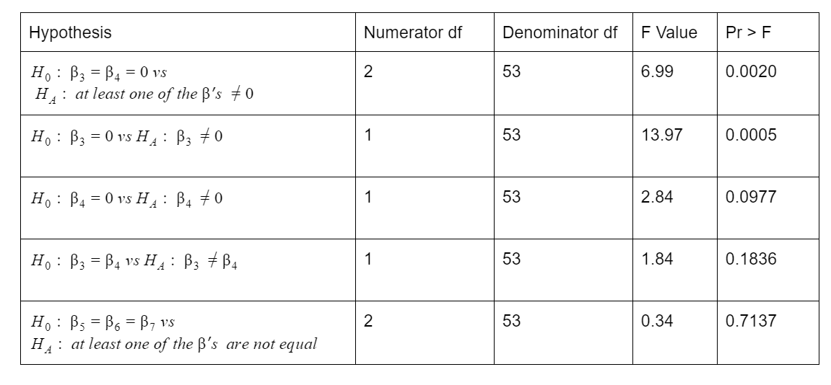

To evaluate the appropriateness of our model fit, we evaluate the residuals of the model to see if any of our assumptions in choosing a linear mixed model are valid. We checked whether there was independence between individuals, linearity in our covariates (random and fixed), independence of random effects from our covariates, and finally the normality of our residuals.

**Figure 5.** Residual Plots

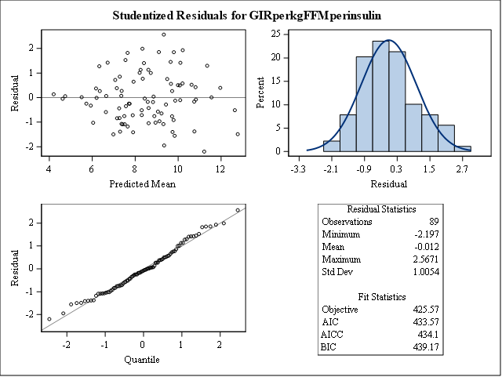

From our studentized residual plot (Figure 5), it seems as if the residuals are randomly scattered around 0 and are normally distributed around 0, with a slight right bias. From our Q-Q plot, we see that most values are centered on the line, but at the tail ends there seems to be some deviation. This deviation does not seem to be overly troublesome, so our assumptions have been validated.

**Figure 6.** Influence Diagnostic Plots

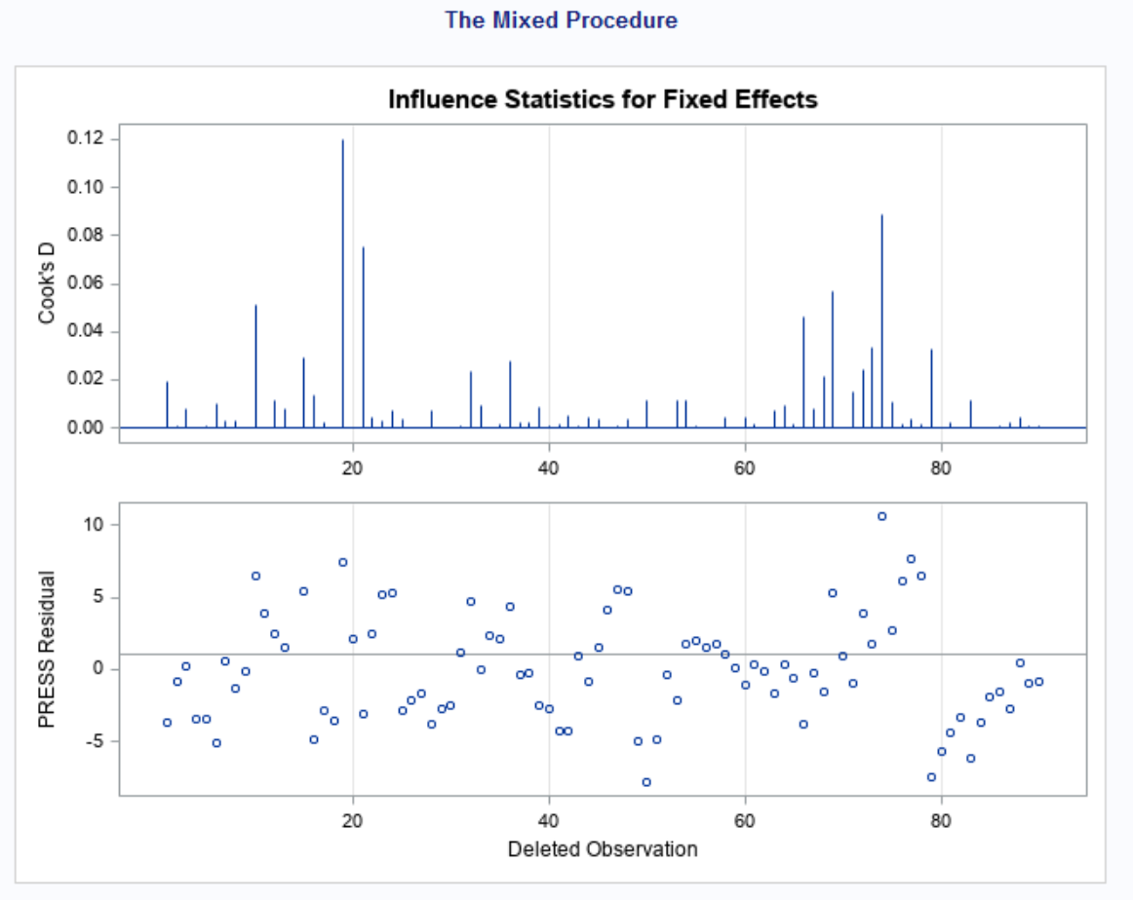

Our plots for influential points show that there are no points in particular that have either high leverage (PRESS), nor are overly influential on the data (Cook’s D).

Discussion

The results of this analysis provide unique insights into how insulin sensitivity changes with exercise regularity. Three months of exercise training (MICT and HIIT) significantly increased whole body insulin sensitivity in the absence of weight loss. Much of the confusion regarding the effects of exercise training on insulin sensitivity revolves around weight-loss that often occurs in short-term exercise training (Despres et al., 1991), because even modest weight loss may have profound effects on glucose tolerance and insulin sensitivity. (Rupnick et al., 2002, Larson-Meyer et al., 2006, Magkos et al., 2016). With the help of the linear mixed model that we developed, we found out that exercise training may directly improve metabolic health. However, our model could not detect any significant difference between groups. This result goes along with other previous findings (Martins et al., 2016, Cocks et al., 2016). This outcome may indicate that HIIT could be a more time efficient mode of exercise for improving metabolic health than MICT because of its shorter time contribution.

Numerous studies reported the increased insulin sensitivity after exercise training (Short et al., 2003, Nassis et al., 2005, DiPietro et al., 2006). However, many of these studies measured the insulin sensitivity after 24 to 48 hours after the exercise session. This may confound interpreting the direct effect of exercise training because there has been a consistent report that acute exercise can instantly increase insulin sensitivity in short amount of time (Thompson et al., 2001). Therefore, it is needed to measure insulin sensitivity after removing potential effects of acute exercise in order to examine the direct impact of training. Our results show that the main effect for time (i.e. days) was likely to be largely driven by the visit 2 (i.e. day 90) with no significant difference between visit 1 and visit 3. This is consistent with the previous finding that exercise induced improvements in insulin sensitivity are short lived (Dela et al., 1992). Therefore, it is inferred that consistent exercise is needed in order to maintain elevated insulin sensitivity levels.

A couple limitations of this study to keep in mind is the lack of control group. While the study compares high and moderate intensity exercise, it does not compare it to individuals who do not work out at all, possibly due to ethical reasons or enrollment issues. Therefore, we could not assess the effect of exercise compared to no exercise. The study included only 31 individuals at only a few time points and the study did not adjust for individuals’ diets.

In the future, the study could expand analysis and methodology in a few different ways. First, researchers might use an ARH(1) model to see how results might change or not change as we would have more timepoints. This study used a random slope to account for unequally spaced measurements but was deemed unnecessary in the model. It is possible that the spacing of the measurements might not impact the variance and covariance between repeated measures. Visit 1 and Visit 2 are further spaced apart but have a higher correlation compared to Visit 2 and Visit 3, which are only 3 days apart. Secondly, further diagnostics would be helpful to consider specific variance-covariance structures. Thirdly, predicting the insulin sensitivity on an individual level would be another helpful step to give clinicians the potential to utilize these results on their individual patients. Fourthly, analysis that investigates the difference between sex would be helpful. So far, the study suggests that females have a larger difference in insulin sensitivity changes with high and moderate intensity workouts. There may be unknown sex differences in responses to exercise worth exploring. Finally, a closer and more in-depth look at the differences in insulin sensitivity at different visits would make for a more comprehensive study.

Appendix

References

Houmard, J. A., Tanner, C. J., Slentz, C. A., Duscha, B. D., McCartney, J. S., & Kraus, W. E. (2004). Effect of the volume and intensity of exercise training on insulin sensitivity. *Journal of applied physiology*, *96*(1), 101-106.

Short, K. R., Vittone, J. L., Bigelow, M. L., Proctor, D. N., Rizza, R. A., Coenen-Schimke, J. M., & Nair, K. S. (2003). Impact of aerobic exercise training on age-related changes in insulin sensitivity and muscle oxidative capacity. *Diabetes*, *52*(8), 1888-1896.

Katz, A., Nambi, S. S., Mather, K., Baron, A. D., Follmann, D. A., Sullivan, G., & Quon, M. J. (2000). Quantitative insulin sensitivity check index: a simple, accurate method for assessing insulin sensitivity in humans. *The Journal of Clinical Endocrinology & Metabolism*, *85*(7), 2402-2410.

Larson-Meyer, D. E., Heilbronn, L. K., Redman, L. M., Newcomer, B. R., Frisard, M. I., Anton, S., ... &

Ravussin, E. (2006). Effect of calorie restriction with or without exercise on insulin sensitivity, β-cell

function, fat cell size, and ectopic lipid in overweight subjects. Diabetes care, 29(6), 1337-1344.

Rupnick, M. A., Panigrahy, D., Zhang, C. Y., Dallabrida, S. M., Lowell, B. B., Langer, R., & Folkman, M. J.

(2002). Adipose tissue mass can be regulated through the vasculature. Proceedings of the National

Academy of Sciences, 99(16), 10730-10735.

Weston, K. S., Wisl.ff, U., & Coombes, J. S. (2014). High-intensity interval training in patients with

lifestyle-induced cardiometabolic disease: a systematic review and meta-analysis. Br J Sports Med, 48(16), 1227-1234.

Tjonna, A. E., Lee, S. J., Rognmo, .., St.len, T. O., Bye, A., Haram, P. M., ... & Kemi, O. J. (2008). Aerobic

interval training versus continuous moderate exercise as a treatment for the metabolic syndrome: a pilot

study. Circulation, 118(4), 346-354.

Little, J. P., Jung, M. E., Wright, A. E., Wright, W., & Manders, R. J. (2014). Effects of high-intensity interval exercise versus continuous moderate-intensity exercise on postprandial glycemic control assessed by continuous glucose monitoring in obese adults. Applied Physiology, Nutrition, and Metabolism, 39(7), 835-841.

Magkos, F., Fraterrigo, G., Yoshino, J., Luecking, C., Kirbach, K., Kelly, S. C., ... & Klein, S. (2016). Effects of

moderate and subsequent progressive weight loss on metabolic function and adipose tissue biology in

humans with obesity. Cell metabolism, 23(4), 591-60

Martins, C., Kazakova, I., Ludviksen, M., Mehus, I., Wisloff, U., Kulseng, B., ... & King, N. (2016). High-intensity interval training and isocaloric moderate-intensity continuous training result in similar improvements in body composition and fitness in obese individuals. *International journal of sport nutrition and exercise metabolism*, *26*(3), 197-204.

Cocks, M., Shaw, C. S., Shepherd, S. O., Fisher, J. P., Ranasinghe, A., Barker, T. A., & Wagenmakers, A. J. (2016). Sprint interval and moderate‐intensity continuous training have equal benefits on aerobic capacity, insulin sensitivity, muscle capillarisation and endothelial eNOS/NAD (P) Hoxidase protein ratio in obese men. *The Journal of physiology*, *594*(8), 2307-2321.

Dela, F., Mikines, K. J., von Linstow, M., Secher, N. H., & Galbo, H. (2006). Effect of training on insulin-mediated glucose uptake in human muscle. *American Journal of Physiology-Endocrinology And Metabolism*, *263*(6), E1134-E1143.

Thompson, P. D., Crouse, S. F., Goodpaster, B. R. E. T. T., Kelley, D. A. V. I. D., Moyna, N. I. A. L. L., & Pescatello, L. I. N. D. A. (2001). The acute versus the chronic response to exercise. *Medicine and science in sports and exercise*, *33*(6 Suppl), S438-45.

Short, K. R., Vittone, J. L., Bigelow, M. L., Proctor, D. N., Rizza, R. A., Coenen-Schimke, J. M., & Nair, K. S. (2003). Impact of aerobic exercise training on age-related changes in insulin sensitivity and muscle oxidative capacity. *Diabetes*, *52*(8), 1888-1896.

Nassis, G. P., Papantakou, K., Skenderi, K., Triandafillopoulou, M., Kavouras, S. A., Yannakoulia, M., ... & Sidossis, L. S. (2005). Aerobic exercise training improves insulin sensitivity without changes in body weight, body fat, adiponectin, and inflammatory markers in overweight and obese girls. *Metabolism*, *54*(11), 1472-1479.

DiPietro, L., Dziura, J., Yeckel, C. W., & Neufer, P. D. (2006). Exercise and improved insulin sensitivity in older women: evidence of the enduring benefits of higher intensity training. *Journal of applied physiology*, *100*(1), 142-149.

Sample Code

ods pdf file = "K:\BIOS 653\project\Output_report.pdf";

/*this version has these variables in the model: Sex Group*days Fatmass_cent MuscleGlycogen*/;

**data** exercise;

infile 'K:\BIOS 653\project\data_biostat653_project.csv'

delimiter = ','

dsd

missover

firstobs = **2**

DSD;

input ID $ Sex $ Group $ Days Fatmass MuscleGlycogen GIRperkgFFMperinsulin;

**run**;

**proc** **print** data = exercise (obs=**10**);

**run**;

**data** exercise_d;

set exercise;

Fatmass_cent = Fatmass - **40.68**;

MuscleGlycogen_cent = MuscleGlycogen-**595.4059**;

**run**;

**proc** **print** data = exercise_d (obs=**10**);

**run**;

title 'variance covariance structure';

title2 'unstructured';

**proc** **mixed** data = exercise_d method=reml;

class ID Group(ref='MICT') Sex Days(ref='0');

model GIRperkgFFMperinsulin = Sex Days Group*Days Fatmass_cent MuscleGlycogen_cent/noint solution;

random intercept/type = un subject = ID g gcorr v vcorr;

repeated Days/type = un subject = ID r rcorr;

**run**;

title 'variance covariance structure';

title2 'ARH(1)';

**proc** **mixed** data = exercise_d method=reml;

class ID Group(ref='MICT') Sex Days(ref='0');

model GIRperkgFFMperinsulin = Sex Days Group*Days Fatmass_cent MuscleGlycogen_cent/noint solution;

random intercept/type = un subject = ID g gcorr v vcorr;

repeated Days/type = ARH(**1**) subject = ID r rcorr;

**run**;

title 'variance covariance structure';

title2 'ANTE(1)';

**proc** **mixed** data = exercise_d method=reml;

class ID Group(ref='MICT') Sex Days(ref='0');

model GIRperkgFFMperinsulin = Sex Days Group*Days Fatmass_cent MuscleGlycogen_cent/noint solution;

random intercept/type = un subject = ID g gcorr v vcorr;

repeated Days/type = ANTE(**1**) subject = ID r rcorr;

**run**;

title 'variance covariance structure';

title2 'CSH';

**proc** **mixed** data = exercise_d method=reml;

class ID Group(ref='MICT') Sex Days(ref='0');

model GIRperkgFFMperinsulin = Sex Days Group*Days Fatmass_cent MuscleGlycogen_cent/noint solution;

random intercept/type = un subject = ID g gcorr v vcorr;

repeated Days/type = CSH subject = ID r rcorr;

**run**;

title 'variance covariance structure';

title2 'CSH';

title3 'sex specific var cov structure';

**proc** **mixed** data = exercise_d method=reml;

class ID Group(ref='MICT') Sex Days(ref='0');

model GIRperkgFFMperinsulin = Sex Days Group*Days Fatmass_cent MuscleGlycogen_cent/noint solution;

random intercept/type = un subject = ID g gcorr v vcorr;

repeated Days/type = CSH group = Sex subject = ID r rcorr;

**run**;

title 'variance covariance structure';

title2 'CSH';

title3 'Group specific var cov structure';

**proc** **mixed** data = exercise_d method=reml;

class ID Group(ref='MICT') Sex Days(ref='0');

model GIRperkgFFMperinsulin = Sex Days Group*Days Fatmass_cent MuscleGlycogen_cent/noint solution;

random intercept/type = un subject = ID g gcorr v vcorr;

repeated Days/type = CSH group = Group subject = ID r rcorr;

**run**;

title 'evaluating need for random slope';

title2 'CSH';

title3 'random slope and random intercept';

**proc** **mixed** data = exercise_d method=reml;

class ID Group(ref='MICT') Sex Days(ref='0');

model GIRperkgFFMperinsulin = Sex Days Group*Days Fatmass_cent MuscleGlycogen_cent/noint solution;

random intercept Days/type = un subject = ID g gcorr v vcorr;

repeated Days/type = CSH subject = ID r rcorr;

**run**;

title 'evaluating need for random slope';

title2 'CSH';

title3 'only random intercept';

**proc** **mixed** data = exercise_d method=reml;

class ID Group(ref='MICT') Sex Days(ref='0');

model GIRperkgFFMperinsulin = Sex Days Group*Days Fatmass_cent MuscleGlycogen_cent/noint solution;

random intercept/type = un subject = ID g gcorr v vcorr;

repeated Days/type = CSH subject = ID r rcorr;

**run**;

title 'variance covariance structure';

title2 'CSH random intercept only';

title3 'hypothesis tests';

**proc** **mixed** data = exercise_d method=reml;

class ID Group(ref='MICT') Sex Days(ref='0');

model GIRperkgFFMperinsulin = Sex Days Group*Days Fatmass_cent MuscleGlycogen_cent/noint solution;

random intercept/type = un subject = ID g gcorr v vcorr;

repeated Days/type = CSH subject = ID r rcorr;

contrast 'betweendays' Days **1** -**1** **0**, Days **0** **1** -**1**, Days **1** **0** -**1**/e;

contrast 'day93 vs day0' Days **0** **1** -**1**/e;

contrast 'day93 vs day90' Days **1** -**1** **0**/e;

contrast 'day90 vs day0' Days **1** **0** -**1** /e;

contrast 'all group*time interact' Group*Days **1** -**1** **0** -**1** **1** **0**, Group*Days **1** **0** -**1** -**1** **0** **1** /e; **0** -**1**/e;

**run**;